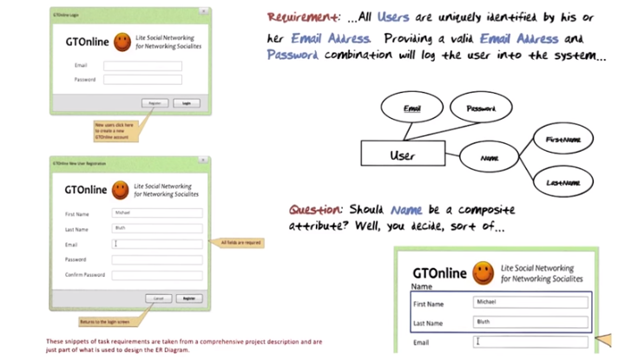
上圖中上面的是log in screen, 下面的是registration screen.

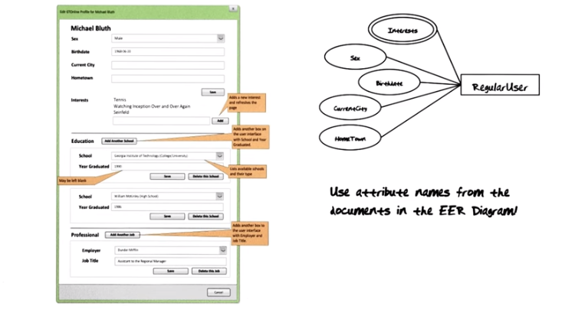
上圖是Edit Profile screen.

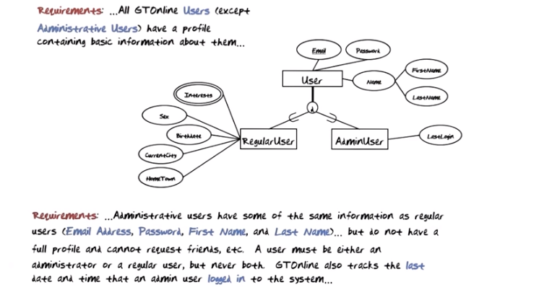
The above figure: a user must either be a Regularuser or an AdminUser, but cannot be both. Therefore, the constraint is disjoint. Textbook中說了, d下面兩個箭頭(或U)表示inherit的方向(此處是除quiz外, 最早出現箭頭的地方)

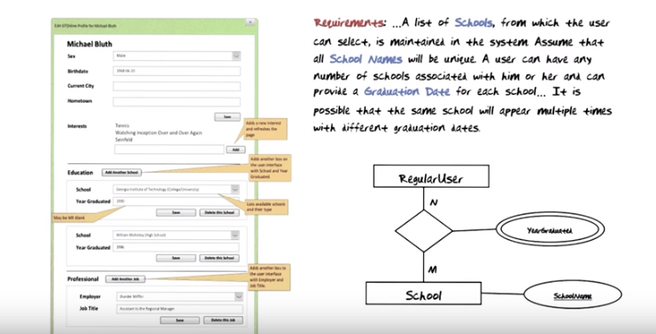
上圖: Edit Profile往下看, 就是Education section.

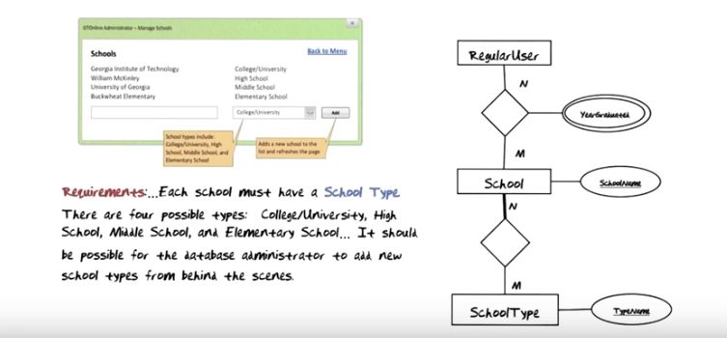
上圖: relation連雙線property的, 都可以這樣理解: 一個RegularUser和一個School可以對應多個YearGraduate, 即同一個人在同一個學校中可以有多個不同的畢業時間. 下下圖中的RegularUser-Employer-JobTitle也可以這樣理解. relation連單線property的, 也可以類似理解.

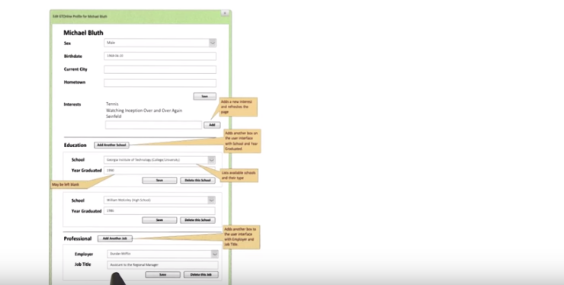
The above figure: at the bottom of the Edit Profile screen is the Professional section.

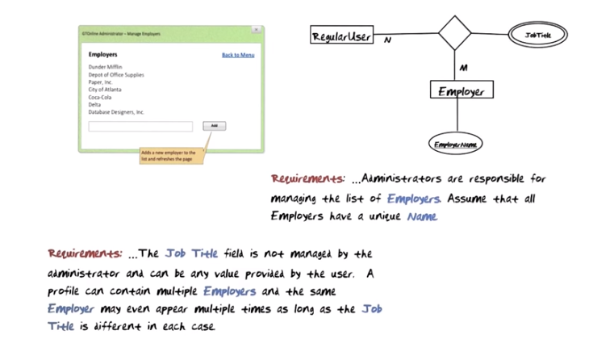

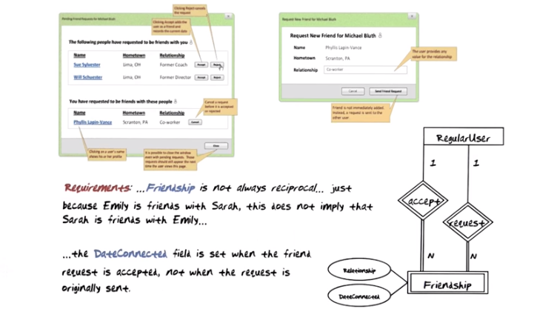

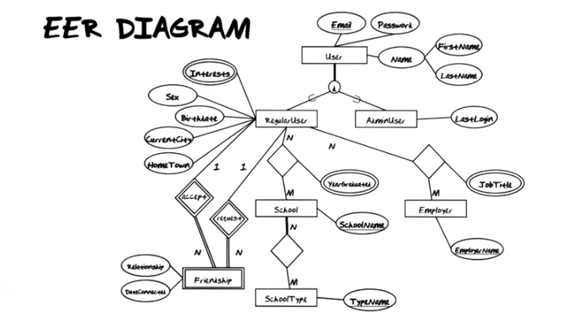

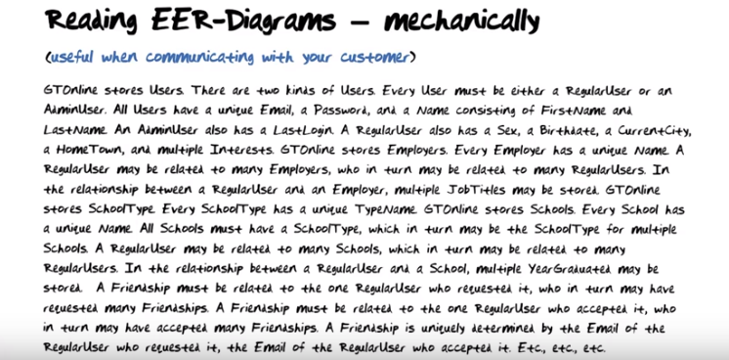
The above figure: Please notice that the way I just summarized Extended-Entity Relationship diagram was quite mechanical in nature. It would actually be possible to write a program that would take as input an Extended-Entity Relationship diagram and then read out in English exactly what it means, no more no less. When you are talking with your customer about your database specificaiton, they would not be able to understand the Extended-Entity Relationship diagram, they might be able to understand this English representation of that diagram.

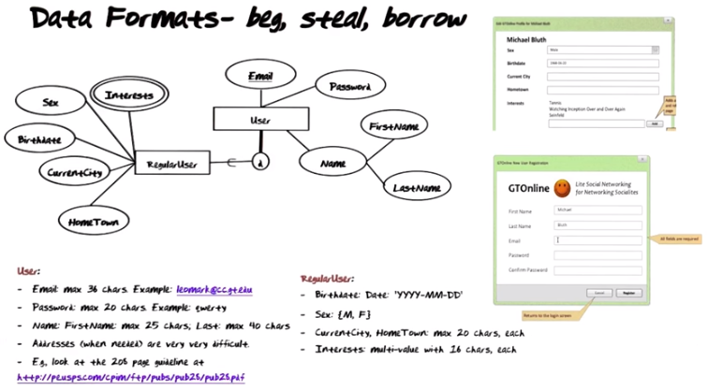
The above figure: Addresses, when needed, are very very difficult to deal with. Couple of years agao when I was looking at address formats, I ran into the United States Postal Service's recommendation for addresses across the world. It's a whopping two hundred-plus page guideline. Guidelines like that takes specilaists to develop, and it takes a lot of time. Instead of every single database to sing out there who needs to create addresses in their database, maybe they should take a look at what other people have done. In general, you can extrapolate their idea into one of the basic concept when it comes to data formatting, namely beg, steal and borrow. If someone already has spent a lot of time thinking about this, why would you do it too?
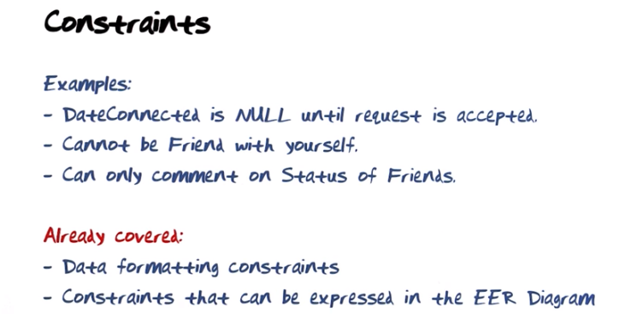

The above figure: Well, it basically leaves us with a set of rules that we can't describe in the database that we can't format out way out of. So there's only one place left to it, and that is to program it into the application program, show that constraints like this are enforced.

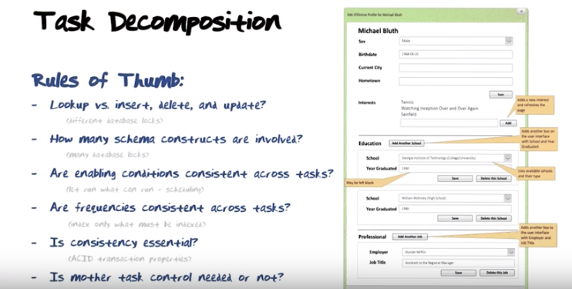
The above figure: for each one of the tasks, we identify in the information flow diagram, we need to talk about whether that's a single task, or whether it should be decomposed. The rules of thumb I'm going to give you are based on a deep understanding of the internal workings of a database management system. In each one of the cases I'm going to give you the rule, and I'm going to tell you what it is based on. Later on, when you do task decompostion, you're going to go through these rules that I'm giving you in order to determine whether the particular task you're looking at should be decomposed or not.

- Lookup vs insert, delete and update?
So from a database management system perspective, difference between whether a task just is a look up task or whether it actually modifies the database through an insertion, deletion, or update. The reason for that is that different database locks are needed in order to support lookups versus chan es to the database. So if many different things take place(即需要look up), then that's a indication that the test should be decomposed.

- How many schema constructs are involved?
The second rule of thumb is based on how big a portion of the database is involved in the operation. The bigger the portion is, the harder it is to acquire all the logs that are needed in order to support concurrent execution of transactions on the database. So if a large number of schema constructs are involved, that would make you want to decompose the task into smaller tasks using smaller portions of the database. (Edit Profile例子中, Clearly there are several different schema constructs involved. There's both the personal information portion for user and for regular user. There's the whole education portion. And there's the whole professional portion. 多個schema原來就是這個意思)

- Are enabling conditions consistent across tasks?
The next rule of thumb is based on what enables the different portions of a task. So if some portion of a task are enabled, then why not let those proceed instead of waiting to later on when there might not be resource available to run those tasks that were earlier enabled. The smaller portions of a task that can run, the easier it is to schedule the task. (View profile例子中, All three are enabled by a user's login or a friend's lookup)

- Are frequencies consistent across tasks?
The next rule of thumb is based on what the frequencies of the things that are done by the task are. If the task contains things that are done with a high frequency and things that are done with a low frequency, it is a good idea to split them apart. The reason is that high frequency things, you want to index to run fast. Whereas low frequency things, you may not need to index.

- Is consistency enssential?
The next really important rule of thumb is related to consistency of the database. Is it really essential that all the pieces of a task get done in one transaction? Or is it okay that things get spread out a little bit over time? An example of that would be transferring money from one bank account to another one.(轉出和轉入要同時做, 因為不能讓轉出的帳戶和轉入的帳戶都同時有同一托錢). So it is very important that all the steps involved are done together. For example, monies must be available in the from account. They must be subtracted from the balance of the from account, and they must be deposited into the to account. All of those things must be done together, in order that you do not end up with an inconsistent database.

- Is mother task control needed or not?
The final rule of thumb is based on the question of whether a mother task is needed to control subtasks. Sometimes you need a mother task, sometimes you do not. The banking example I just gave you certainly needs a mother task (View profile例子中, all three of the must be done in order to display the information on the View Profile screen. So a mother task is needed to make sure that all three things get done). We're later going to see things that may not need a mother task.

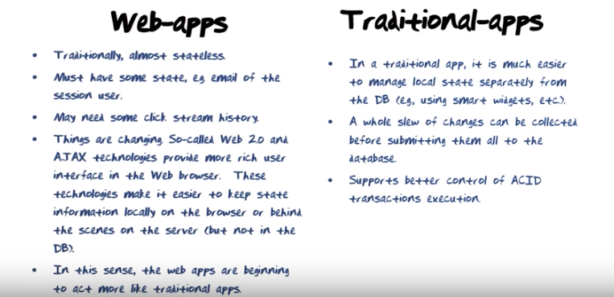

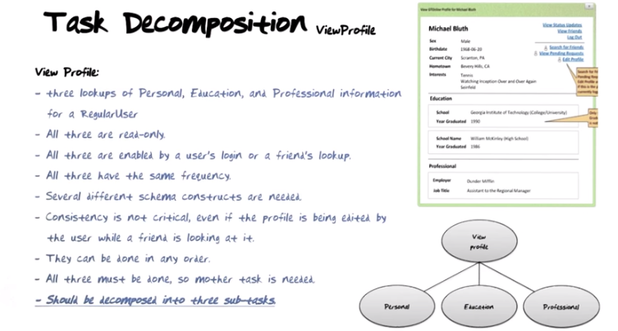

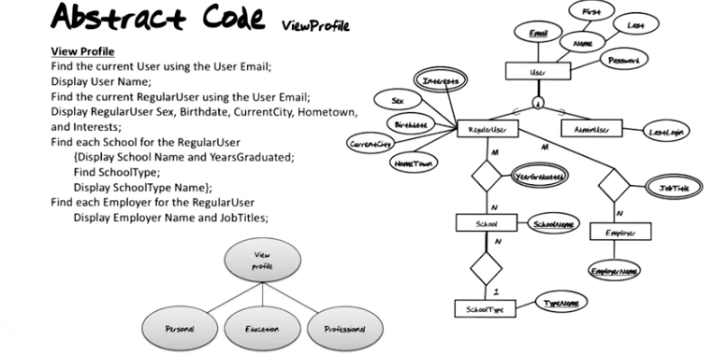

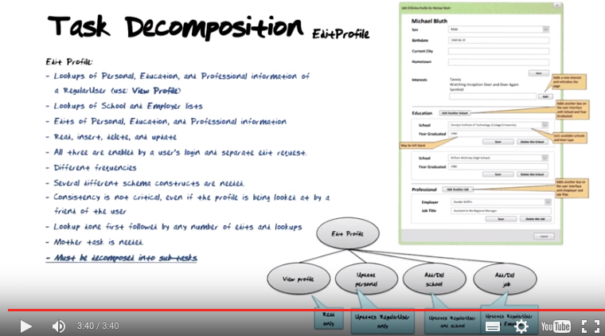

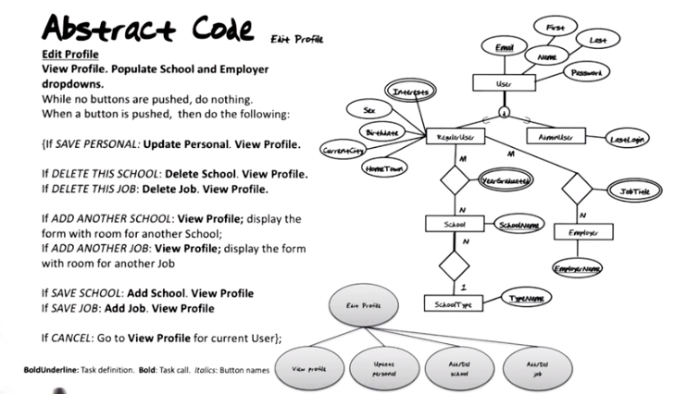
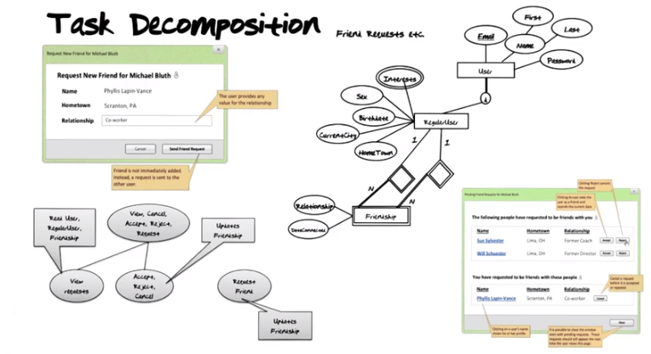

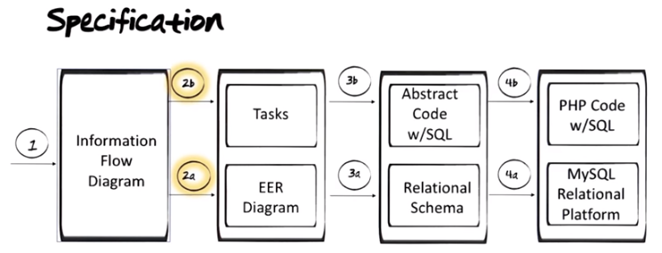
其實看之前的原圖更清楚:

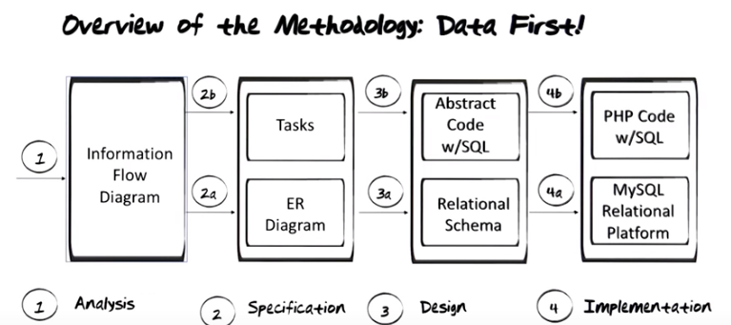


The figure above: Before we go any further, we need a small detour to study an additional database tool or technique.

